FQHC Materials

Order Form
Organization Name:
Contact Name:
Address:
City/State/Zip Code:
Email:
Phone Number:
Shipping Address if different from above:

Qty | Item | Description | Unit Price | Line Total
 | FQHC Pins | FQHC Lapel Pins | $1.50
 | FQHC Brochure | FQHC Four-Page Informational Brochure | Compliments of PACHC
 | FQHC Window Cling | FQHC Clear Window Sticker | Compliments of PACHC
 | FQHC Decal 6.5x10 | FQHC Weather Resistant Vinyl Decal | Compliments of PACHC
 | FQHC Decal 9x14 | FQHC Weather Resistant Vinyl Decal | Compliments of PACHC
 |  |  | Sales Tax
 |  |  | Total
Make all checks payable to PACHC or complete the credit card information box below.
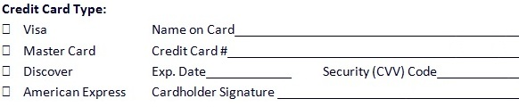

NOTE: All credit card payments will appear on your monthly credit card statement as “Paypal: PACHC.”
Thank you for your order!

PACHC 1035 Mumma Road, Suite 1, Wormleysburg, PA 17043
Phone: 717-761-6443 Fax: 717-761-8730 pachc@pachc.org

